**Malmesbury Town Council**

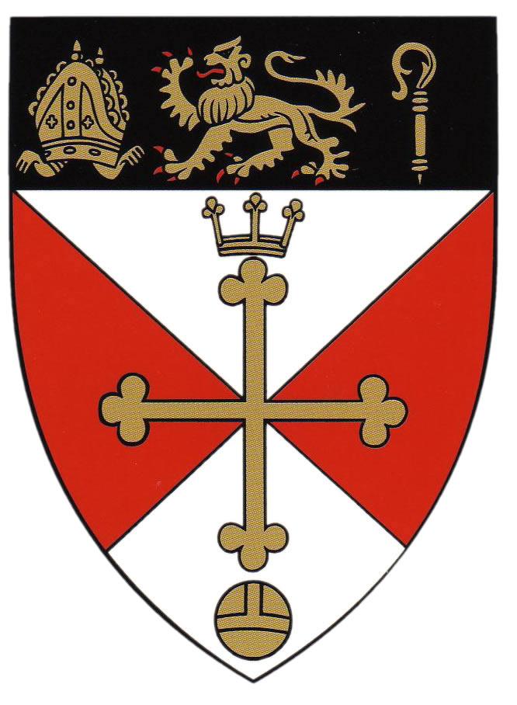(ENGLAND’S OLDEST BOROUGH - CHARTER GRANTED 880)

Claire Mann Town Hall

Town Clerk Malmesbury

SN16 9BZ

Telephone: (01666) 822143

(01666) 823748

E-mail: tic@malmesbury.gov.uk

|  |  |  |
| --- | --- | --- |
| **RETAILERS/BUSINESS APPLICATION FORM**  **HIGH STREET PLUS ART GALLERY**  **SATURDAY 23rd AUGUST 2025 TO SUNDAY 21st SEPTEMBER 2025** | | |
| **Full Name:** |  | |
| **Business:** |  | |
| **Address:** |  | |
| **Contact Number:** |  | |
| **Email Address:** |  | |
| **DISCLAIMER**  **You are to display the artwork in a safe place, but at the artist’s own risk. Retailers, business owners and Malmesbury Town Council will not be liable for theft, damage or any other monetary loss associated with this project.**  **You consent to our using photos or other reproductions of the artwork, which includes paper format, online, in the public domain.**  **By signing this form, you are consenting to our using photos or other reproductions of the artwork and your premises and the like, which include paper format, online, in the public domain and may also include a description of the artwork and artist. Also, that artists, the Town Team, members of the public and others may also make and use images, with details, because your artwork will be on public display.**  **By signing this form, you are confirming that you consent to the terms and conditions of the High Street Art Gallery Plus as set out by** **Community Engagement and Town Promotions Committee, Malmesbury Town Council.** | | |
| **Signed:** | | **Date:** |