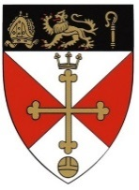
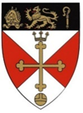 Malmesbury in Bloom –Multi-Media Art
Competition 2022

Entry Form
Name
Class
School
Home
Email address

Please tick the age group you wish to enter:

4 years and under

5 -7 years

8 -9 years

- 10 -11 years

12 years and over

Closing Date : Friday 22nd July

