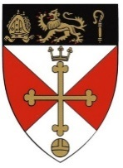
Malmesbury in Bloom – Garden Competition 2022
Entry Form

Please tick the category/categories you wish to enter;

 Category 1 Window Boxes, Hanging Baskets, Containers
 Category 2 Courtyard Gardens and Patios and Small Garden
 Category 3 Large Garden (more than 10m x 10m)
 Category 4 Street/Road or Area
 Category 5 Commercial Premises, incl Pubs, Hotels, Restaurants
 Category 6 Wild Flower area
 Category 7 Vegetable Patch

Name
Address to be judged
Telephone Number
Email

Entries close on Friday 15th July. Judging will take place on Friday 22nd July.
You will be contacted a few days ahead to arrange a judging visit.
Presentation Evening Friday 16th September 2022

